# Final Project Report

**MaitriLok : Social Media MERN Web App**

{ Team Id: SWTID1742907331 }

{ Members: [shashankasthana2022@vitbhopal.ac.in](mailto:shashankasthana2022@vitbhopal.ac.in) [shreyaasthana2022@vitbhopal.ac.in](mailto:shreyaasthana2022@vitbhopal.ac.in) , [sanskarusretay2022@vitbhopal.ac.in](mailto:sanskarusretay2022@vitbhopal.ac.in) , [parthsinha2022@vitbhopal.ac.in](mailto:parthsinha2022@vitbhopal.ac.in) }

**Table of Content**

**Final Project Report** **1**

**1. INTRODUCTION** **2**

1.1 Project Overview 2

1.2 Purpose 2

**2. IDEATION PHASE** **3**

2.1 Problem Statement 3

2.2 Empathy Map Canvas: 4

2.3 Brainstorming 5

**3. REQUIREMENT ANALYSIS** **8**

3.1 Customer Journey map 8

3.2 Solution Requirement 8

3.3 Data Flow Diagram 10

3.4 Technology Stack 10

**4. PROJECT DESIGN** **12**

4.1 Problem Solution Fit 12

4.2 Proposed Solution 13

4.3 Solution Architecture 13

**5. PROJECT PLANNING & SCHEDULING** **14**

5.1 Project Planning 14

**6. FUNCTIONAL AND PERFORMANCE TESTING** **17**

6.1 Performance Testing 17

**7. RESULTS** **21**

7.1 Output Screenshots 21

**8. ADVANTAGES & DISADVANTAGES** **28**

8.1 ADVANTAGES 28

8.2 DISADVANTAGES 28

**9. CONCLUSION** **29**

**10. FUTURE SCOPE** **29**

**11. APPENDIX** **31**

# 1. INTRODUCTION

## 1.1 Project Overview

Introducing our revolutionary social media app! Designed to redefine online connections, our platform offers an intuitive and innovative space for seamless communication and engagement.Break down barriers and enhance collaboration with real-time messaging. Whether you're sharing ideas, collaborating on projects, or simply having fun conversations, our messaging feature allows for seamless interaction and understanding.

Never miss a moment with our convenient post saving functionality. Capture important posts, articles, or inspiring content for later access and sharing with your followers. Your valuable discoveries are preserved, ensuring nothing gets lost in the vast social media landscape.

Your privacy and security are paramount. Our app employs robust encryption to safeguard your data, ensuring all communications remain confidential and protected from unauthorized access.Step into a new era of online connections and communication. Discover the unmatched convenience of seamless messaging, in-app notifications, stories– all within our game-changing social media app. Connect, engage, and explore more together!

## 1.2 Purpose

The purpose of this project is to develop a fully functional social media platform using the MERN (MongoDB, Express.js, React, Node.js) stack. This platform will allow users to connect, share content, and engage in meaningful interactions.

The key objectives of this project are:

1. User Engagement & Connectivity – Enable users to create profiles, add friends/followers, and interact through posts, comments, and likes.

2. Real-time Communication – Implement real-time messaging and notifications to enhance user experience.

3. Content Sharing – Provide users with the ability to upload images, videos, and text-based posts.

4. Scalability & Performance – Utilize MongoDB for efficient data storage and retrieval, ensuring smooth performance even with high user activity.

5. Security & Authentication – Implement JWT-based authentication, secure password storage, and access control mechanisms.

6. Responsive & Intuitive UI – Build a modern and user-friendly interface using React.js for seamless navigation.

7. API Development & Optimization – Develop RESTful APIs with Express.js and Node.js to efficiently handle backend operations.

# 

# 2. IDEATION PHASE

## 2.1 Problem Statement

| **Date** | **10 April 2025** |
| --- | --- |
| **Team ID** | **SWTID1742907331** |
| **Project Name** | **MaitriLok : Social Media App** |
| **Maximum Marks** | **2 Marks** |

**Customer Problem Statement:**

| **Problem Statement (PS)** | **I am (Customer)** | **I’m trying to** | **But** | **Because** | **Which makes me feel** |
| --- | --- | --- | --- | --- | --- |
| PS-1 | New user | Register and explore the app | I don’t see an easy signup process or social login | Only email/password registration is available | Frustrated and less motivated |
| PS-2 | Regular user | Customize my theme or look and feel | There is no color selection or theme toggling | The UI is fixed | Less in control of my experience |
| PS-3 | Social user | Chat with my network | Messages are delayed or don’t update live | Chat lacks real-time functionality | Disconnected |
| PS-4 | Content creator | Share a post | The editor is basic and lacks formatting features | There’s no rich text or media options | Limited and less expressive |
| PS-5 | New user | Find friends or users I know | The search bar doesn’t give relevant results | It doesn’t support name suggestions or filtering | Annoyed and helpless |
| PS-6 | Curious user | View someone’s profile | Profile pages look incomplete or outdated | Users can’t edit all profile info | Less connected to others |
| PS-7 | Daily user | Check recent posts from my network | My feed isn’t updated in real-time | There’s no smart post refresh logic | Out of sync |
| PS-8 | Mobile user | Use the app smoothly | Some components break on small screens | The layout isn’t fully responsive | Irritated while browsing |
| PS-9 | Privacy-conscious user | Control who sees my posts | There are no privacy settings per post | Feature is not implemented yet | Vulnerable |
| PS-10 | Regular user | Save some important posts | I don’t see any option to bookmark or save | The post save feature is missing | Disappointed |

## 2.2 Empathy Map Canvas:

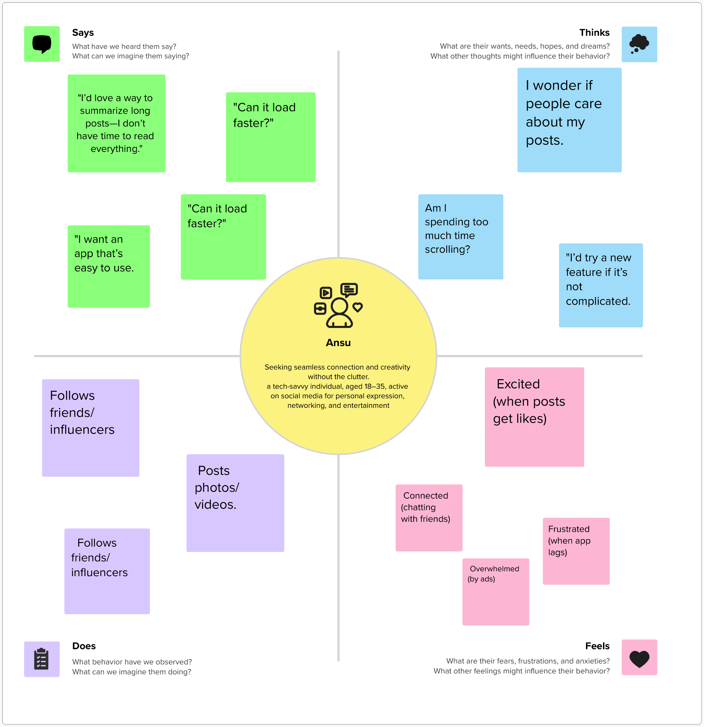

## 2.3 Brainstorming

**Step-1: Team Gathering, Collaboration and Select the Problem Statement**

Our team began by forming a collaborative environment where every member could freely share ideas and expectations. Through regular discussions and brainstorming sessions, we identified common interests and goals. After evaluating various real-world challenges, we selected the idea of building a MERN stack-based social media application, aiming to enhance user interaction and digital connectivity in a secure and modern interface.

**Step-2: Brainstorm, Idea Listing and Grouping**

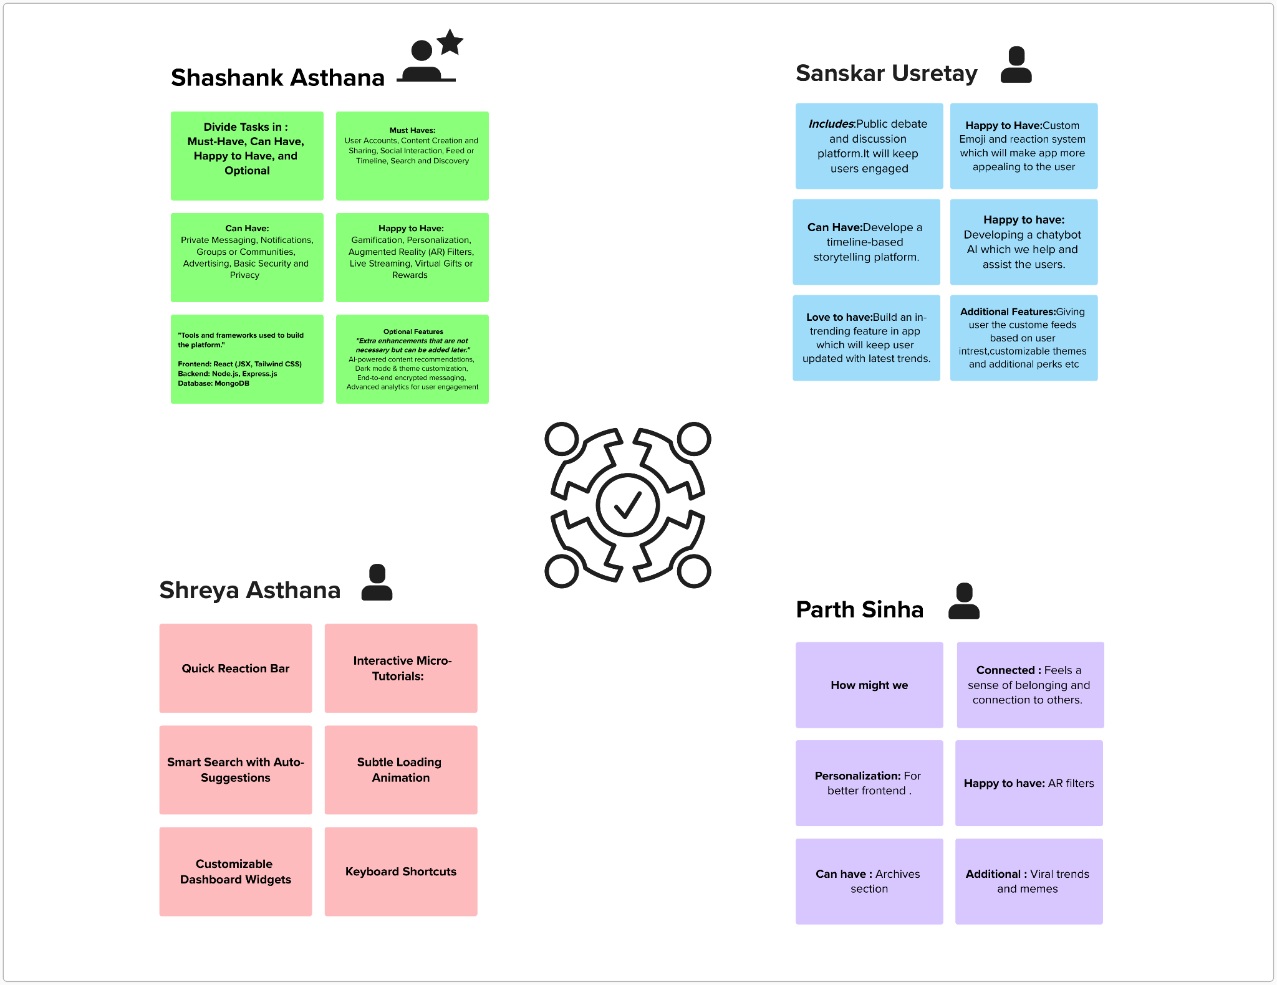

**Step-3: Idea Prioritization**

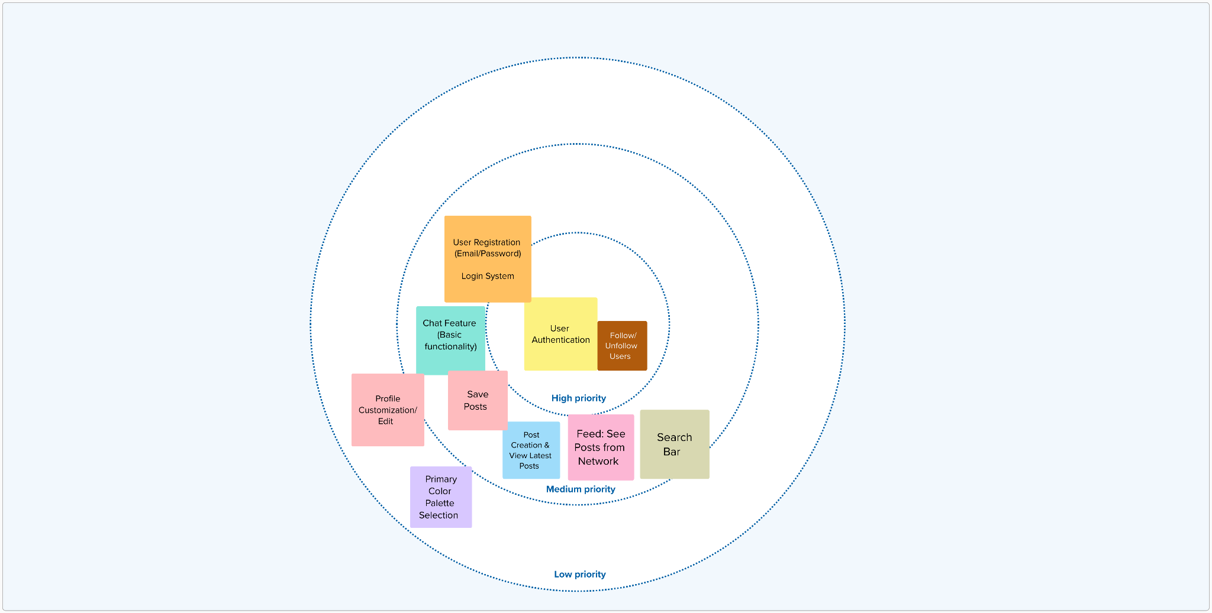

# 

# 3. REQUIREMENT ANALYSIS

| Date | **10 April , 2025** |
| --- | --- |
| Team ID | **SWTID1742907331** |
| Project Title | **MaitriLok : Social Media App** |
| Maximum Marks | **4 Marks** |

## 3.1 Customer Journey map

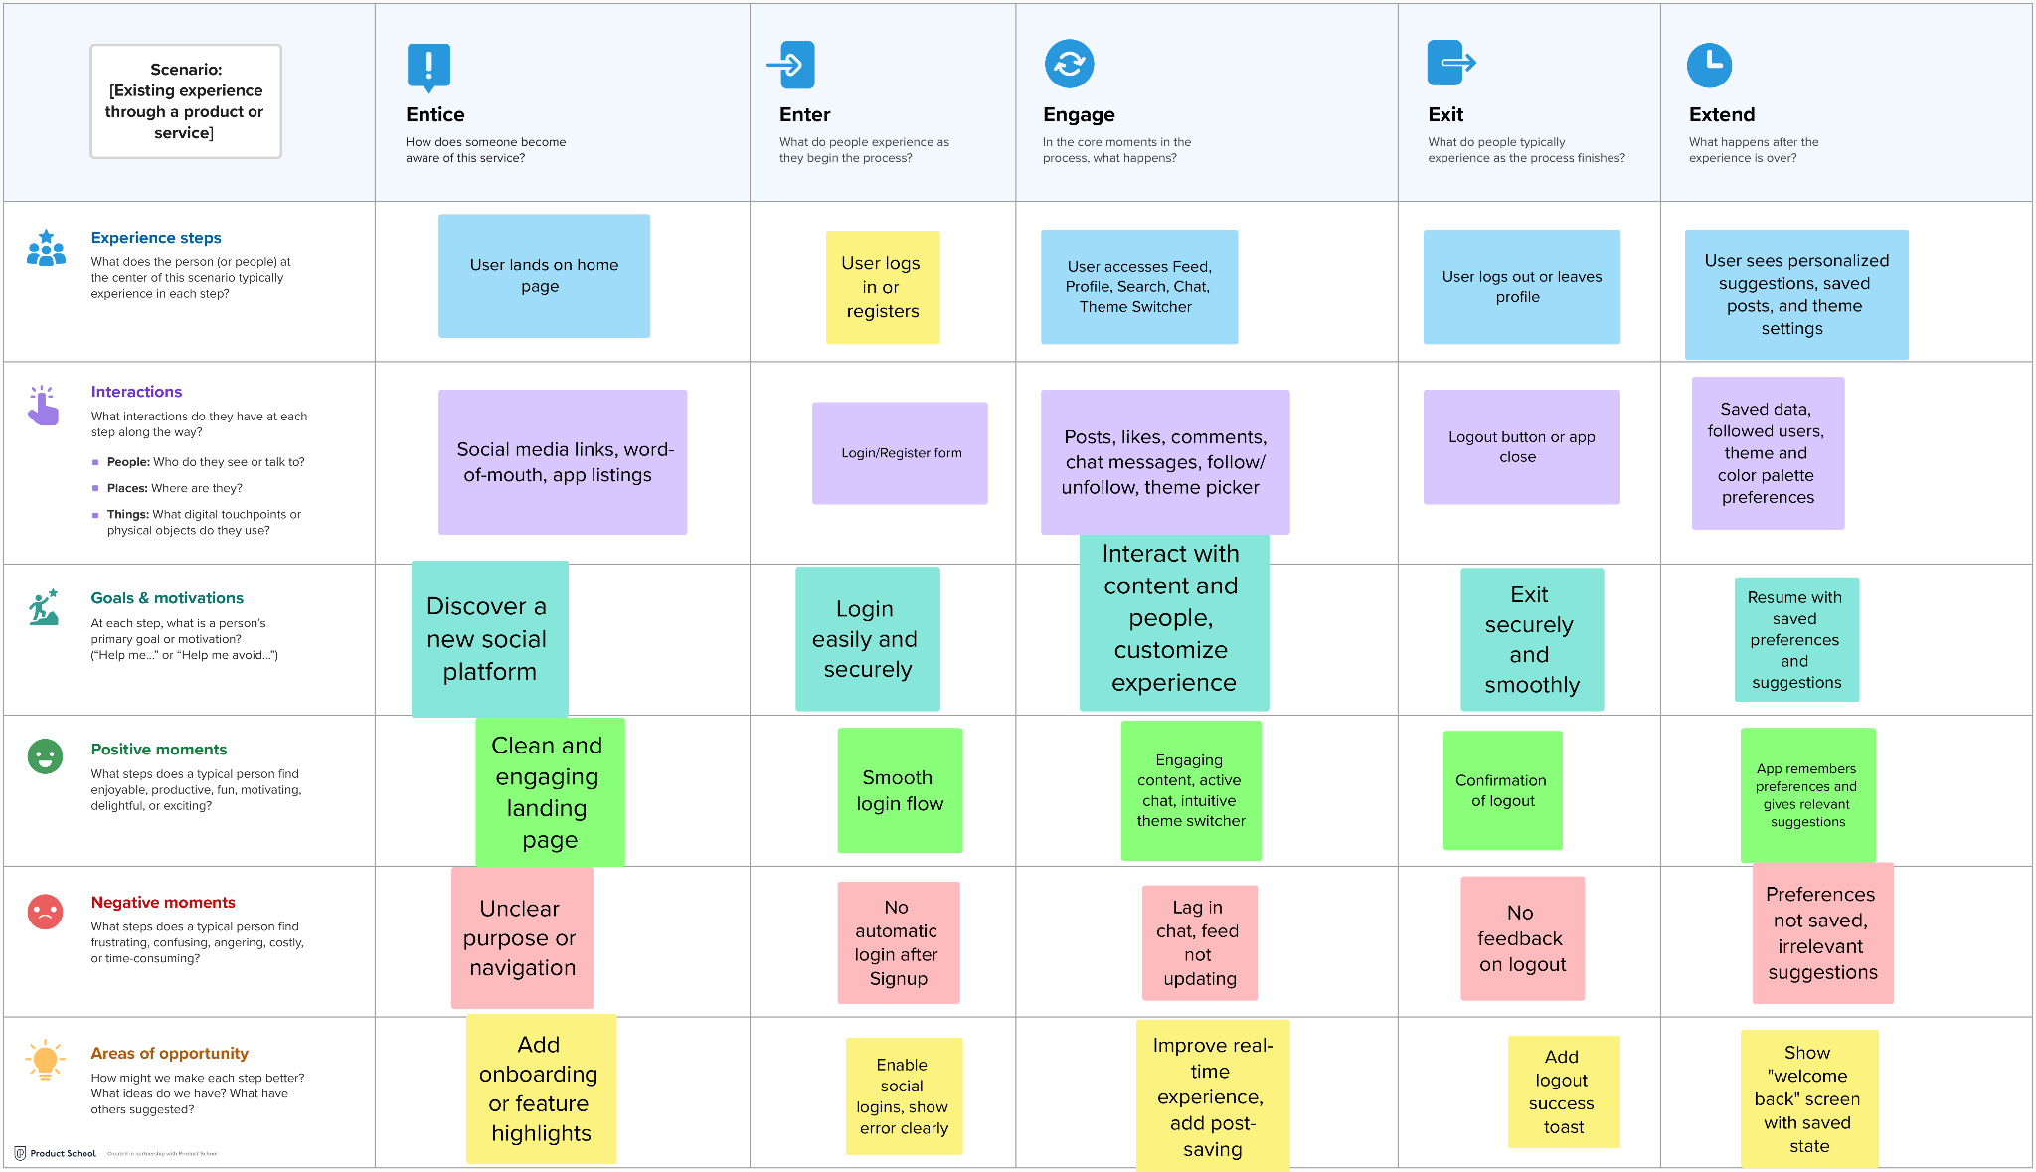

## 

## 3.2 Solution Requirement

| Date | **10 April 2025** |
| --- | --- |
| Team ID | **SWTID1742907331** |
| Project Name | **MaitriLok : Social Media App** |
| Maximum Marks | **4 Marks** |

**Functional Requirements:**

Following are the functional requirements of the proposed solution.

| **FR No.** | **Functional Requirement(Epic)** | **Sub Requirement (Story / Sub-Task)** | **Related Files/Components** |
| --- | --- | --- | --- |
| FR-1 | User Registration | Registration through Form  Login/logout functionality | SignUp.jsx , Login.jsx , authRoutes.js  Logout.jsx, authMiddleware.js |
| FR-2 | User Profile Management | Profile Creation and editing | UserProfile.jsx, EditProfile.jsx, User.js |
| FR-3 | Content Creation and sharing | Create, edit and delete posts | CreatePost.jsx, Post.jsx, postRoutes.js |
| FR-4 | Real time features | Live Chat and messaging system | ChatList.jsx, chatRoutes. js, Chats.js |
| FR-5 | Search and user Posts | Search for Users, Posts | SearchBar.jsx, userRoutes. js, postRoutes. js |
| FR-6 | User panel | User account management | UserProfile.jsx, userController.js |

**Non-functional Requirements:**

Following are the non-functional requirements of the proposed solution.

| **FR No.** | **Non-Functional Requirement** | **Description** | **Implement Reference** |
| --- | --- | --- | --- |
| NFR-1 | **Usability** | For anyone who wants to connect to social media | Simple UI in Feed.jsx,Home.jsx |
| NFR-2 | **Security** | Secure API endpoints | authMiddleware.js,JWT usage |
| NFR-3 | **Reliability** | Regular Backups | Firebase integration for image storage |
| NFR-4 | **Performance** | Fast Page loads | Loading.jsx,Tailwind for fast rendering |
| NFR-6 | **Scalability** | Horizontal Scaling using cloud services | Firebase+Vercel/Render deployment |

## 3.3 Data Flow Diagram



## 

## 3.4 Technology Stack (Architecture & Stack)

| Date | **10 April 2025** |
| --- | --- |
| Team ID | **SWTID1742907331** |
| Project Name | **MaitriLok : Social Media App** |
| Maximum Marks | **4 Marks** |



We used the MERN Stack — MongoDB, Express.js, React.js, and Node.js — for full-stack development. For styling, we used Tailwind CSS, and to handle authentication and security, we implemented JWT and bcryptjs. Firebase Storage was used for image uploads and storing media URLs.

| **S.no** | **Components** | **Description** | **Technology** |
| --- | --- | --- | --- |
| **1** | User Interface | Web UI | HTML , TailwindCss , React |
| **2** | Application Logic-1 | Handles user auth, posts, profile logic | Node.js, Express.js |
| **3** | Application Logic-2 | Media upload and URL handling | Firebase Storage SDK |
| **4** | Application Logic-3 | Authentication & Authorization | JWT, bcryptjs |
| **5** | Database | Stores user data, posts, comments | MongoDB |
| **6** | Cloud Database | Hosted NoSQL database | MongoDB Atlas |

# 4. PROJECT DESIGN

## 4.1 Problem Solution Fit

| Date | 10 April 2025 |
| --- | --- |
| Team ID | SWTID1742907331 |
| Project Name | MaitriLok : Social Media App |
| Maximum Marks | 2 Marks |

## 

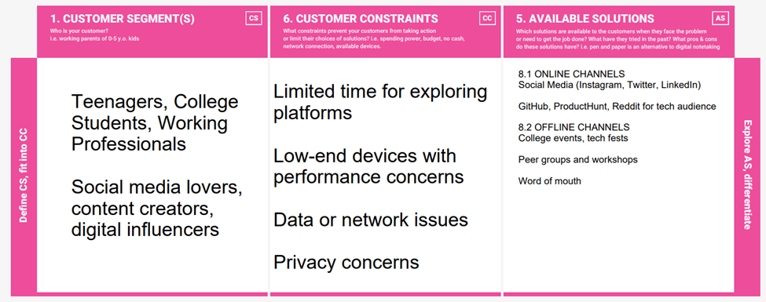

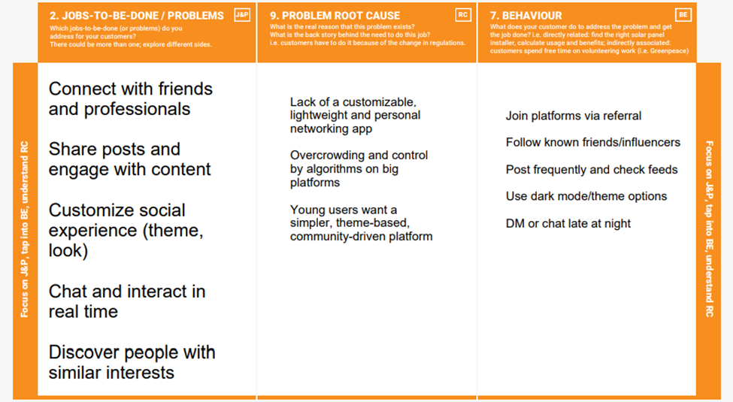

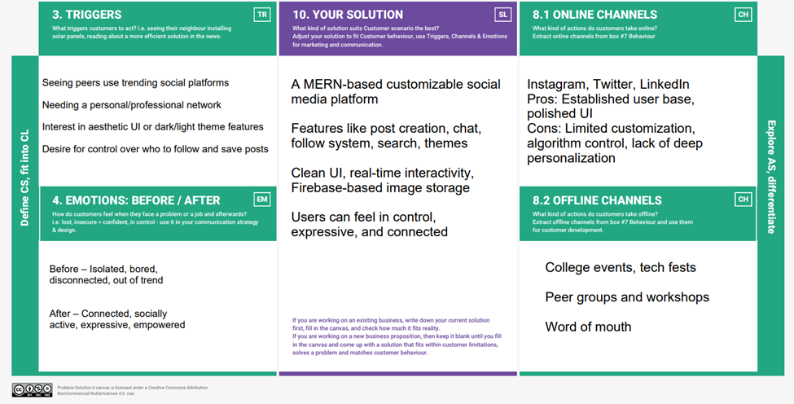

## 

## 4.2 Proposed Solution

| **S.No.** | **Parameter** | **Description** |
| --- | --- | --- |
| 1 | Problem Statement (Problem to be solved) | Existing social platforms often lack meaningful user engagement, personalized experiences, and simplified interaction mechanisms. There is limited control over content discovery, network building, and theming. |
| 2 | Idea / Solution Description | Maitrilok is a MERN-stack based social media platform with user registration/login, feed with post creation/edit/delete/like/comment/save, search functionality, theme customization, real-time chat, and a dynamic "My Network" section showing latest posts from followed users. |
| 3 | Novelty / Uniqueness | Includes real-time chat between mutual followers, theme switcher with custom color palettes, personalized network feed, role-based content management, and smooth UX across user actions like post saving, commenting, and following. |
| 4 | Social Impact / Customer Satisfaction | Encourages digital friendships and communities with better personalization, promotes safe and respectful interactions, and boosts satisfaction through custom UI and intelligent network curation. |
| 5 | Business Model (Revenue Model) | Freemium model with ad support, premium features like profile highlights and visibility boosts, sponsored posts, and partnership opportunities with influencers and local communities. |
| 6 | Scalability of the Solution | Built on scalable cloud infrastructure (MongoDB Atlas, Node.js backend), capable of supporting large user base, feature extensions like mobile app integration, multilingual support, and additional interaction modes (e.g., stories or video posts). |

## 4.3 Solution Architecture



# 

# 5. PROJECT PLANNING & SCHEDULING

## 5.1 Project Planning

| Date | **10 April 2025** |
| --- | --- |
| Team ID | **SWTID1742907331** |
| Project Name | **Social Media App (MERN)** |
| Maximum Marks | **5 Marks** |

**Product Backlog,sprint schedule and Estimation (4 marks)**

| **Sprint** | **Functional Requirement (Epic)** | **User Story No.** | **User Story / Task** | **Story Points** | **Priority** |
| --- | --- | --- | --- | --- | --- |
| Sprint-1 | Registration | USN-1 | As a user, I can register by entering email, password, and confirming password | 2 | High |
| Sprint-1 | Login | USN-2 | As a user, I can log in with email & password | 1 | High |
| Sprint-2 | Profile View | USN-3 | As a user, I can view other users’ profile | 2 | Medium |
| Sprint-2 | Theme System | USN-4 | As a user, I can change theme primary color | 3 | Medium |
| Sprint-3 | Feed | USN-5 | As a user, I can view latest posts from self | 2 | High |
| Sprint-3 | Feed | USN-6 | As a user, I can view posts from my network | 5 | High |
| Sprint-3 | Feed | USN-7 | As a user, I can search for users or posts | 3 | High |
| Sprint-4 | Follow System | USN-8 | As a user, I can chat in real-time with others | 5 | High |
| Sprint-5 | Post Saving | USN-9 | As a user, I can save any post for later | 2 | High |
| Sprint-5 | Saved Posts | USN-10 | As a user, I can save posts for later | 2 | Medium |

**Project Tracker,Velocity and Burnout graph(4 marks)**

| **Sprint** | **Total Story Points** | **Duration** | **Sprint Start Date** | **Sprint End Date (Planned)** | **Story Points Completed (as on Planned End Date)** | **Sprint Release Date (Actual)** |
| --- | --- | --- | --- | --- | --- | --- |
| Sprint-1 | 20 | 1 Day | 04 Apr 2025 | 04 Apr 2025 | 20 | 04Apr 2025 |
| Sprint-2 | 20 | 1 Day | 05 Apr 2025 | 05 Apr 2025 | 18 | 05Apr 2025 |
| Sprint-3 | 20 | 1 Day | 06 Apr 2025 | 06 Apr 2025 | 16 | 06Apr 2025 |
| Sprint-4 | 20 | 1 Day | 07 Apr 2025 | 07 Apr 2025 | 14 | 07Apr 2025 |
| Sprint-5 | 20 | 1 Day | 08 Apr 2025 | 08 Apr 2025 | 20 | 08Apr 2025 |

**Velocity =** Total Completed Story Points / No. of Sprints = (20+18+16+14+20)/5 = 88/5 = 17.6

# 

# 6. FUNCTIONAL AND PERFORMANCE TESTING

## 6.1 Performance Testing

**User Acceptance Testing (UAT) Template**

| Date | **10-04-2025** |
| --- | --- |
| Team ID | **SWTID1742907331** |
| Project Name | **MaitriLok: Social Media App** |
| Maximum Marks | **10** |

**Project Overview:**

Project Name: MaitriLok: Social Media App

Project Description: A customizable and interactive MERN Stack-based social media platform that supports user posts, chatting, following, theme customization, and profile viewing.

Project Version: v1.0

Testing Period: 09 April 2025 to 10 April 2025

**Testing Scope:**

User Registration/Login

Profile View (Self and Others)

Post Creation and Feed Viewing

Search Functionality

Theme Customization

Chat Functionality

Follow/Unfollow

Save Post

**Testing Environment:**

URL/Location: VS Code

Frontend : localhost:5173

Backend: localhost:3000

Credentials (if required): you can sign in with any email and password

**Test Cases:**

| **Test Case ID** | **Test Scenario** | **Test Steps** | **Expected Result** | **Actual Result** | **Pass/Fail** |
| --- | --- | --- | --- | --- | --- |
| TC-001 | User Registration | Open Signup > Fill Form > Submit | Account created and redirected to login page | Account created and redirected to login page | [Pass/Fail] |
| TC-002 | Login with valid credentials | Open Login > Enter Email/Password | Redirected to Home/Feed | Redirected to Home/Feed | [Pass/Fail] |
| TC-003 | View another user's profile | Search User > Click Profile | Profile data visible | Profile data visible | [Pass/Fail] |
| TC-004 | Post creation | Go to Create Post > Submit post | Post visible in feed | Post visible in feed | [Pass/Fail] |
| TC-005 | Chat with another user | Open Chat > Send Message | Message sent and received in real-time | Message sent and received in real-time | [Pass/Fail] |
| TC-006 | Change Theme | Toggle theme/color | App color changes instantly | App color changes instantly | [Pass/Fail] |
| TC-007 | Follow/unfollow user | Go to profile > Follow/Unfollow | Button toggles and network updates | Button toggles and network updates | [Pass/Fail] |
| TC-008 | Save a post | Click Save icon on post | Post saved to user profile | Post saved to user profile | [Pass/Fail] |

**Bug Tracking:**

| **Bug ID** | **Bug Description** | **Steps to reproduce** | **Severity** | **Status** | **Additional feedback** |
| --- | --- | --- | --- | --- | --- |
| BG-001 | Chat not updating in real-time | Open chat > Send > Other user idle | Medium | Open | Might need socket retry |
| BG-002 | Theme not saved after refresh | Change theme > Reload | Low | In progress | Consider localStorage |

**Sign-off:**

Tester Name:

Date:

Signature:

**Notes:**

● Ensure that all test cases cover both positive and negative scenarios.

● Encourage testers to provide detailed feedback, including any suggestions for improvement.

● Bug tracking should include details such as severity, status, and steps to reproduce.

● Obtain sign-off from both the project manager and product owner before proceeding with deployment.

# 

# 7. RESULTS

## 7.1 Output Screenshots

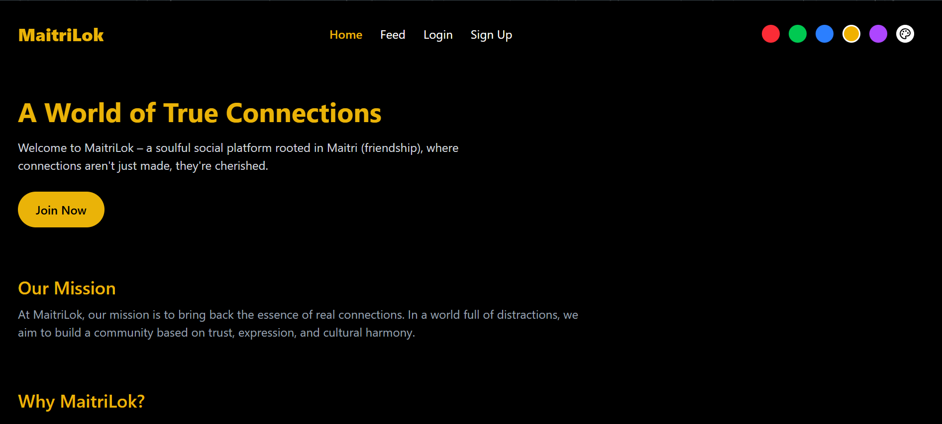

Landing Page

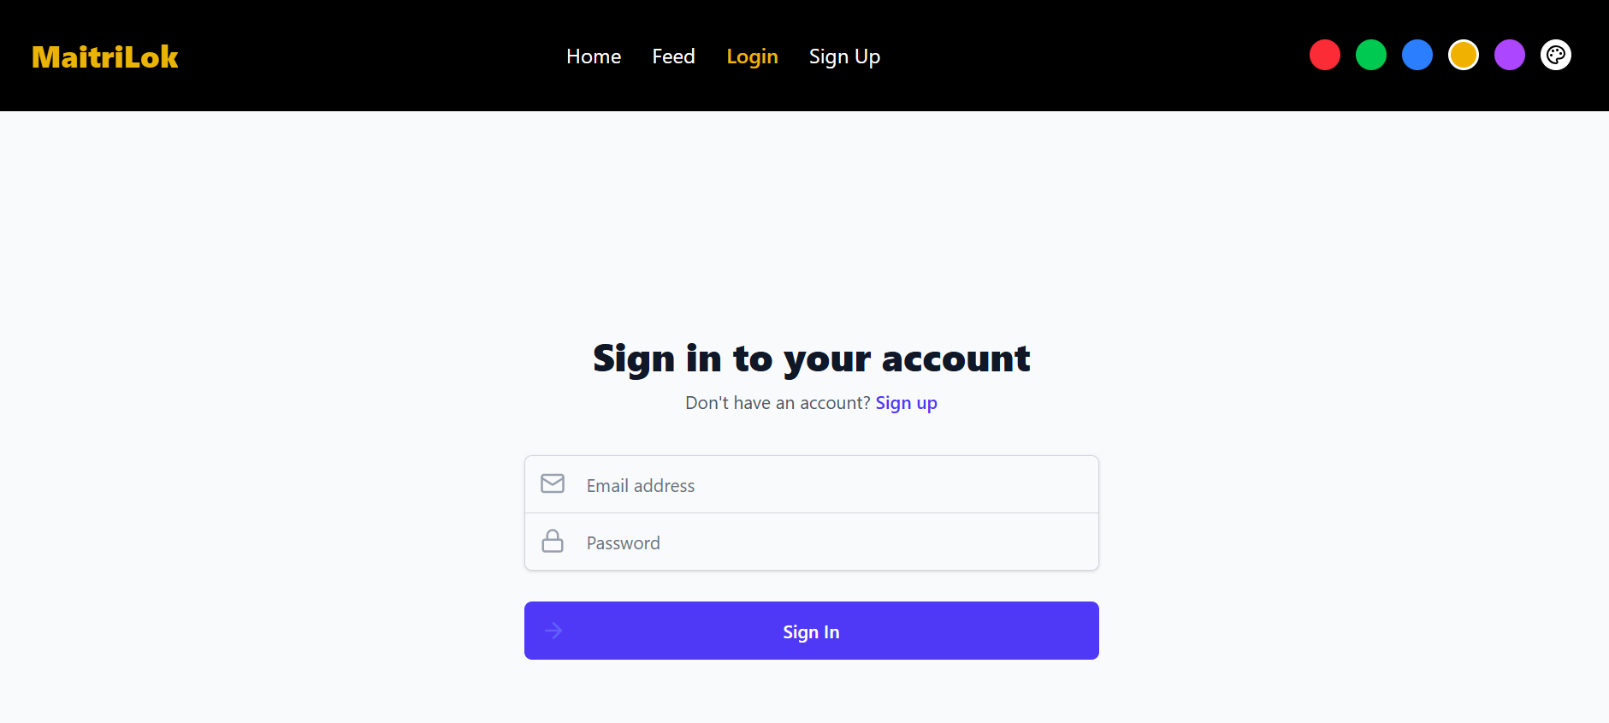

Login

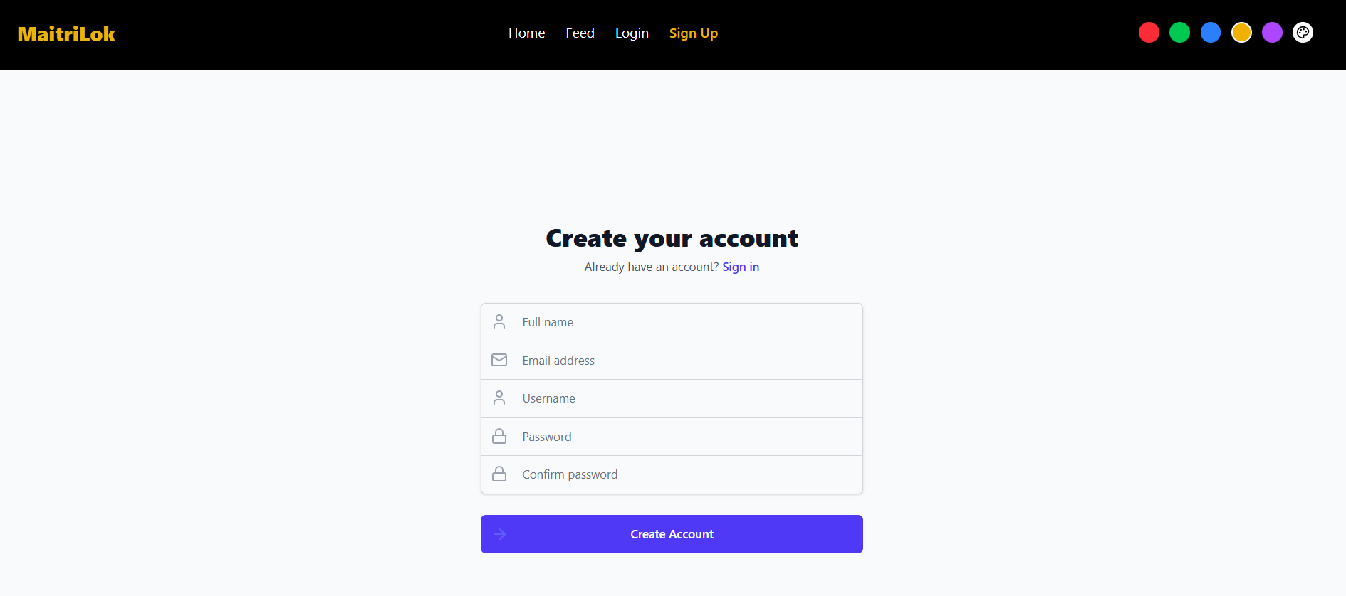

Signup

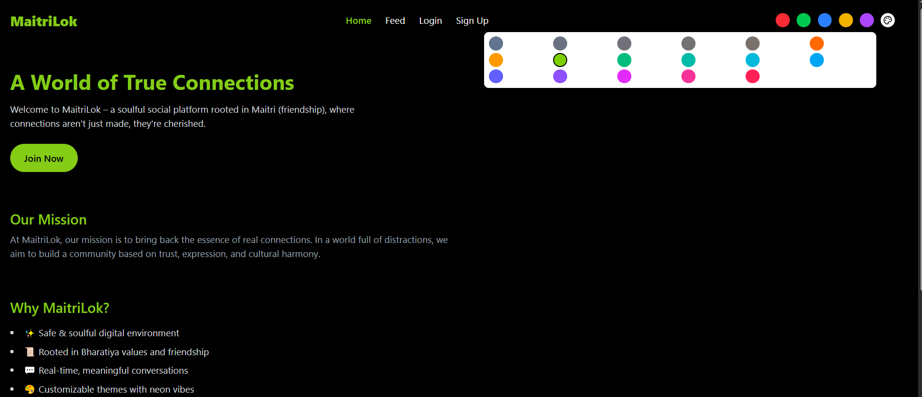

ThemeSwitcher

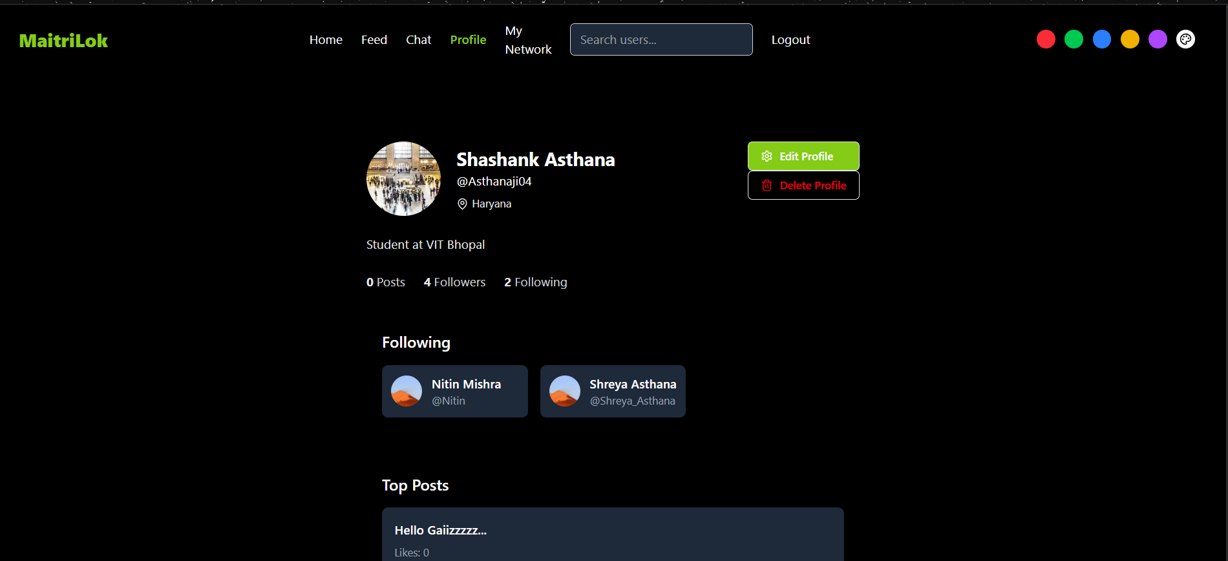

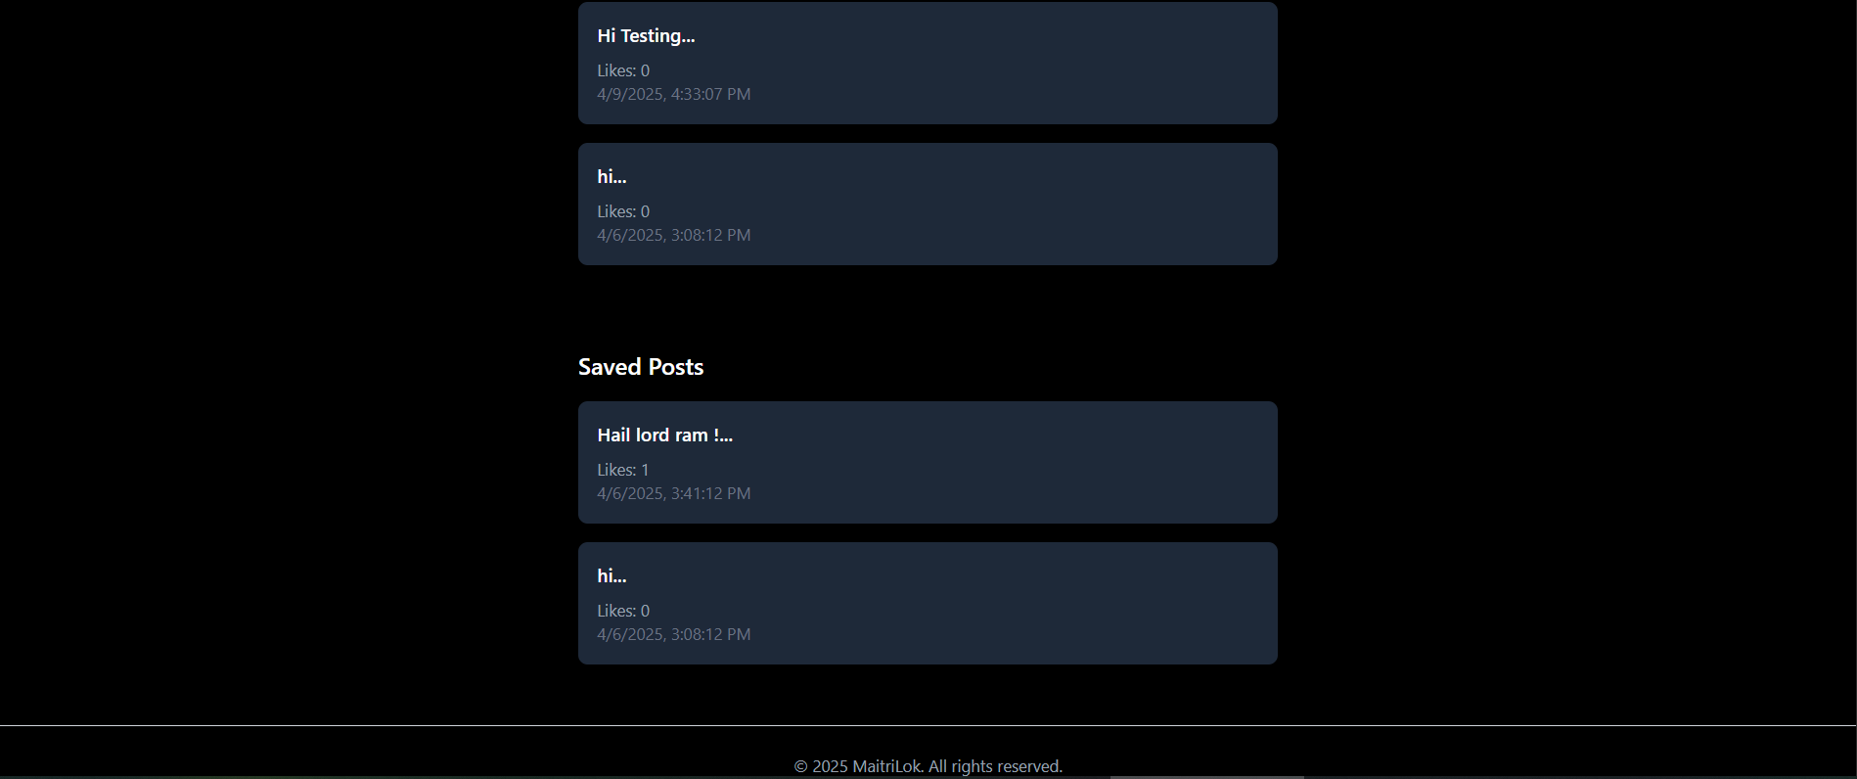

Profile Section after Login

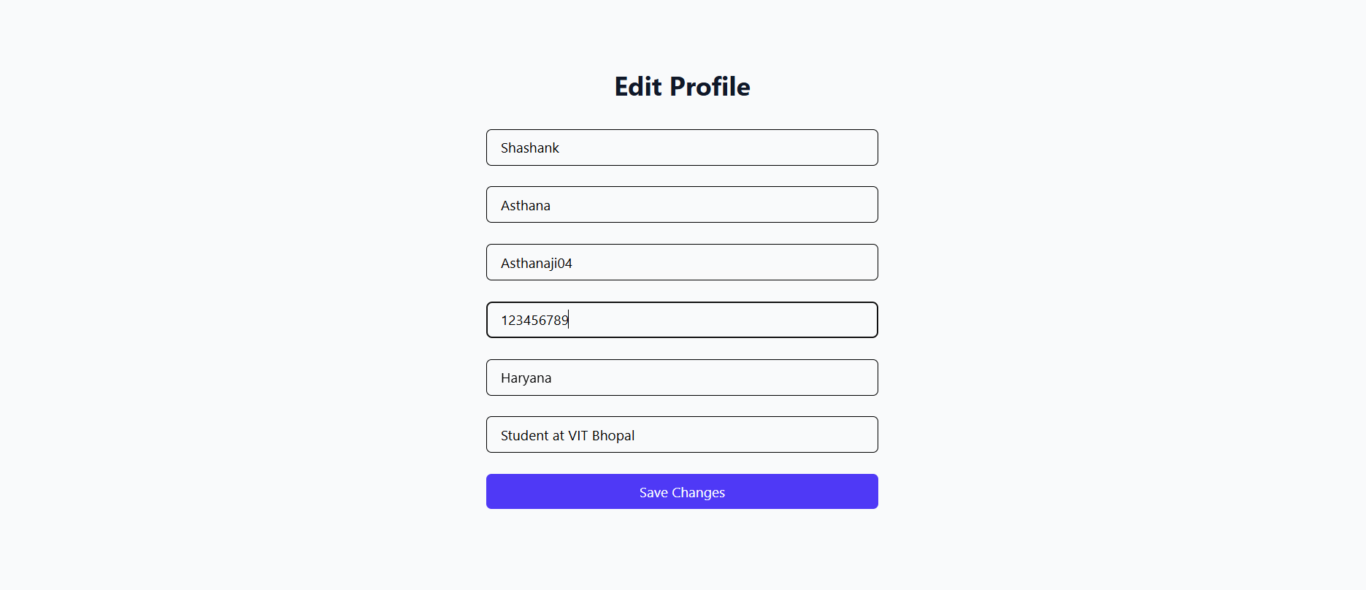

Edit Profile

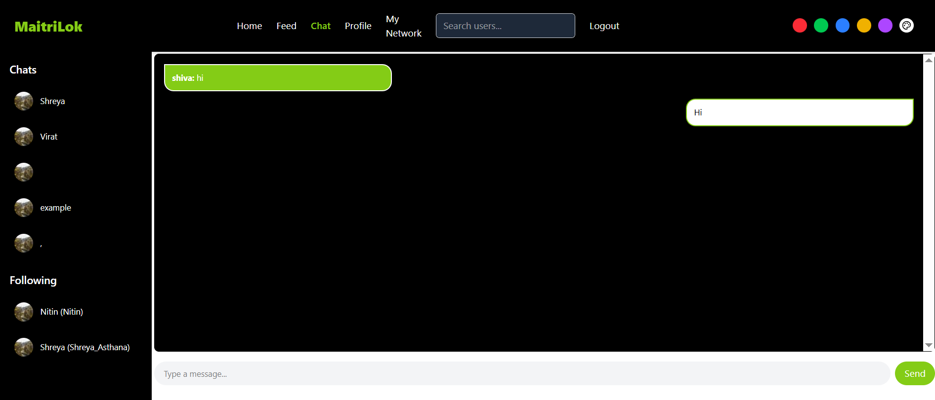

Chat Page

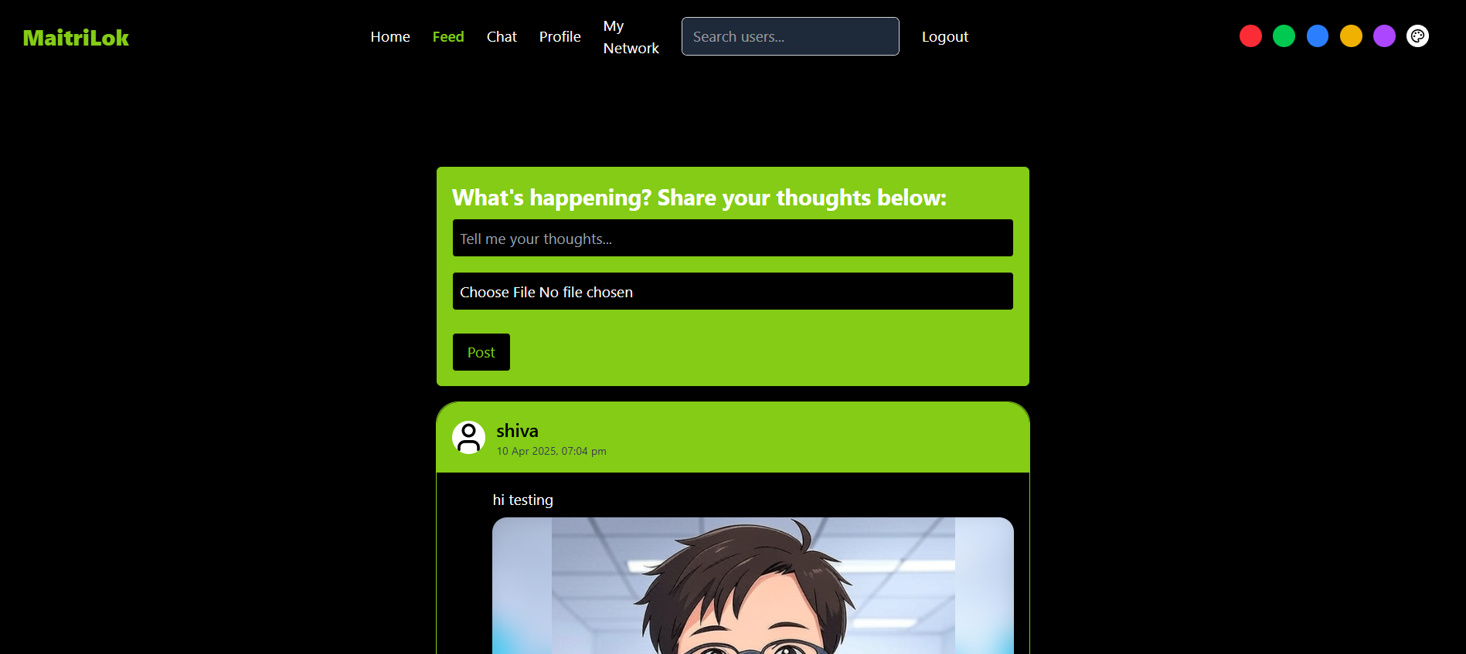

Feed Page

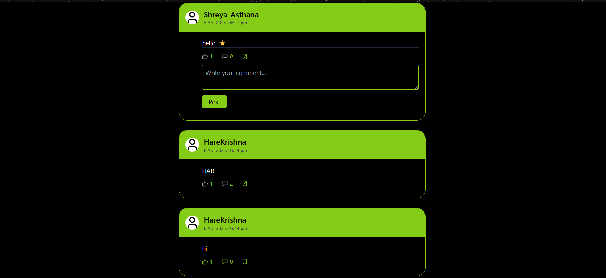

Like and save posts

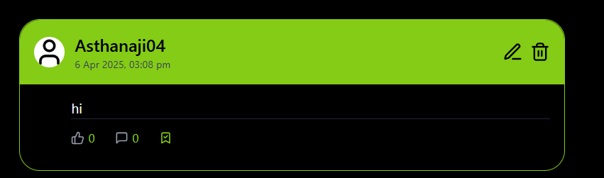

Edit and Delete Post also

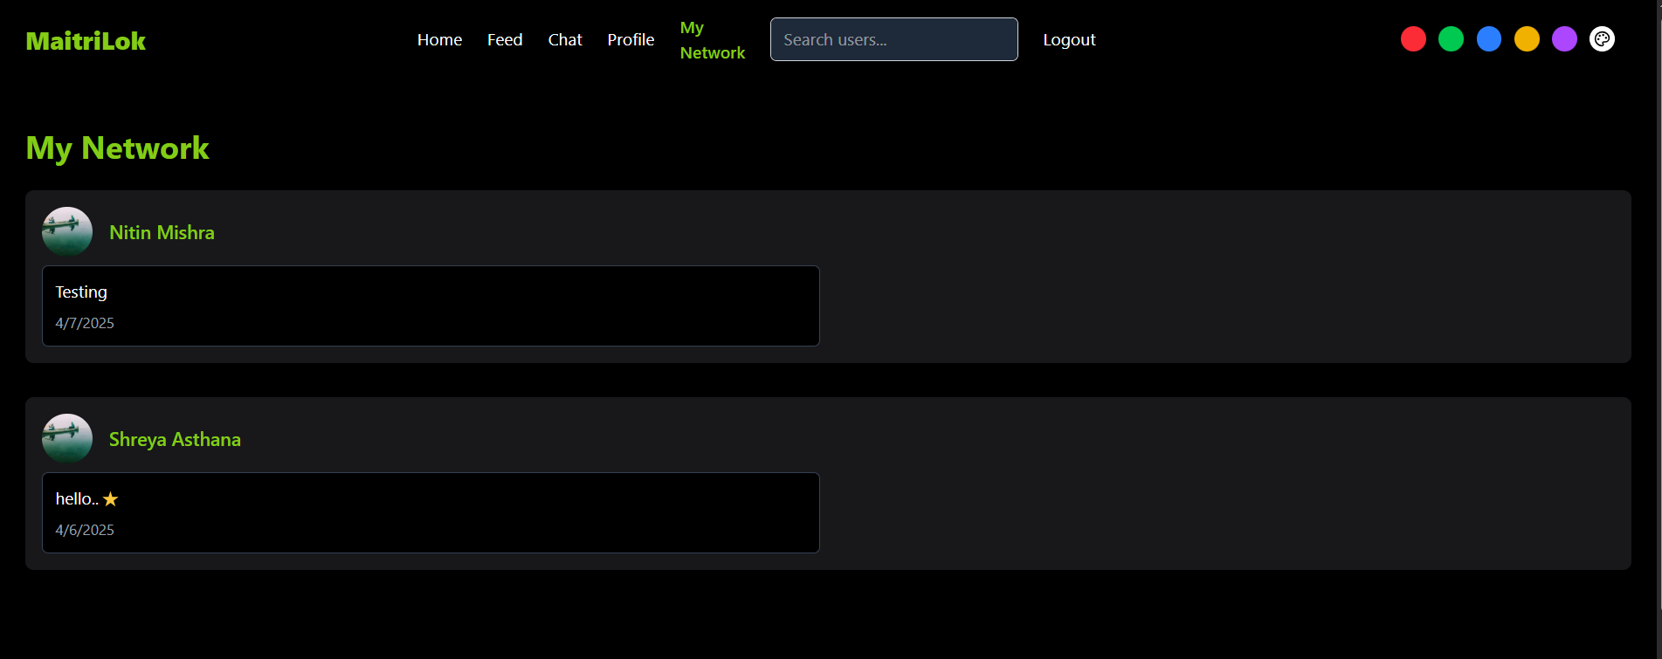  
My Network

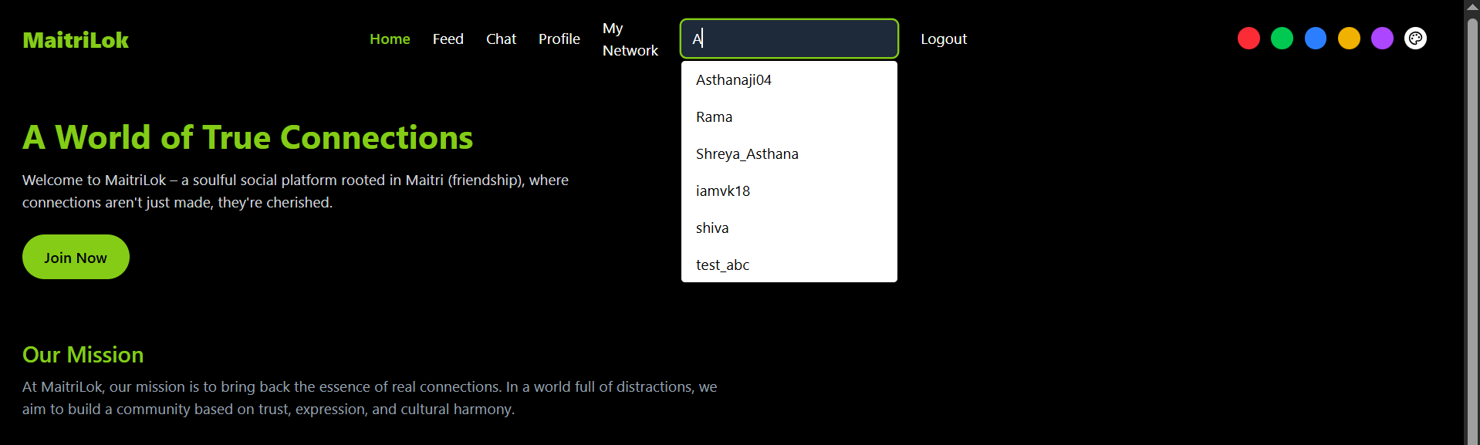

Search Bar

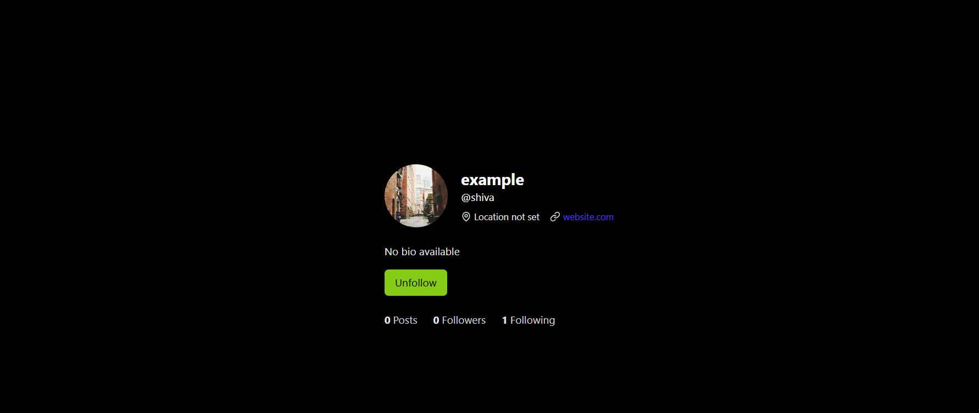

Other User’s Profile

# 

# 8. ADVANTAGES & DISADVANTAGES

## 8.1 ADVANTAGES

1. Simplified Authentication System: The application uses a basic email and password login mechanism, ensuring a secure and user-friendly authentication process without unnecessary complexity.

2. Customizable User Interface: Users can personalize their experience through theme color options and toggle between dark and light modes, enhancing usability and comfort.

3. Real-Time Chat Integration: The real-time chat feature fosters seamless user interaction and improves engagement, making conversations instant and more interactive.

4. Rich Post Functionality: Users can create, view, save, and explore posts shared within their network, promoting content sharing and community involvement.

5. Follow System: Inspired by popular social media platforms, the follow system allows users to build and grow their own social circle, encouraging user retention and interaction.

6. Performance-Optimized SPA: Developed using the MERN stack, the application offers a fast, responsive single-page experience, ensuring smooth navigation and performance.

7. Search Functionality: An integrated search bar allows users to easily find profiles and content, improving overall navigation and user satisfaction.

## 8.2 DISADVANTAGES

1. Limited Login Options: The application currently supports only email and password authentication. The absence of social login options (e.g., Google or Facebook) may affect user onboarding convenience.

2. No Email Verification Mechanism: User accounts are created without verification, which increases the risk of spam registrations or fake profiles.

3. Lack of Notification System: The system does not include push or email notifications, which may result in users missing important updates or interactions.

4. Basic Privacy Controls: Users have limited control over post visibility. Features such as setting posts to public, private, or visible to followers only are not yet implemented.

5. No Admin Dashboard or Analytics: There is no dedicated admin panel for managing users, monitoring posts, or analyzing platform activity, which limits administrative control and oversight.

# 

# 9. CONCLUSION

**Core Functionality Implementation:**

The social media platform MaitriLok successfully incorporates the fundamental features required for a functional and engaging user experience. Key functionalities include user registration, secure email/password-based login, user profile viewing, feed display, real-time chat, a follow system, search capabilities, and the ability to save posts. These collectively establish a solid foundation for a modern social networking application.

**Development Strategy and Sprint Execution:**

The project adopted an agile development approach, organizing feature implementation into structured sprints. This strategy allowed for focused execution, timely progress tracking, and ensured that the core functionalities were developed with performance and responsiveness as key priorities.

**Bug Identification and Resolution:**

During testing and development, several issues were identified, including post reload inconsistencies, real-time chat synchronization challenges, and glitches in the post-saving functionality. While some of these issues have been resolved, others remain under review and are scheduled for resolution in upcoming development cycles.

**Future Scope and Enhancements:**

Planned future enhancements include the integration of advanced authentication methods (such as social logins and email verification), implementation of robust privacy settings, development of a comprehensive notification system, and expansion of communication features (including voice/video calls). Additionally, an administrative dashboard with user and content analytics is proposed to provide better control and insights for platform administrators.

**Overall Assessment:**

MaitriLok effectively delivers a foundational social media experience through its core features and user-centric design. With ongoing development and the planned addition of advanced capabilities, the platform is well-positioned to evolve into a more competitive, secure, and feature-rich solution for social networking.

# 10. FUTURE SCOPE

To enhance the platform’s functionality, user experience, and scalability, several advancements have been identified for future implementation in *MaitriLok*. These are outlined below:

**A. Advanced Authentication and Onboarding**

* **Social Login Integration:** Support for third-party authentication providers such as Google and Facebook to simplify the onboarding process and improve user accessibility.
* **Email Verification:** Implementation of confirmation emails to validate user registrations and reduce spam or fake accounts.

**B. Enhanced Privacy and Security**

* **Granular Privacy Controls:** Introduction of detailed post visibility settings (e.g., public, friends-only, private) to give users more control over their content.
* **Two-Factor Authentication (2FA):** Addition of 2FA to enhance account security and protect against unauthorized access.

**C. Notification System**

* **Push and Email Notifications:** Real-time notifications for user interactions, including new messages, likes, comments, and follows, to keep users informed and engaged.

**D. Expanded Communication Features**

* **Advanced Chat Functionalities:** Integration of modern chat features such as typing indicators, read receipts, and group messaging.
* **Multimedia Communication:** Support for voice and video calling to enrich user interaction and broaden communication options.

**E. Administrative Panel and Analytics**

* **Admin Dashboard:** Development of a backend interface for administrators to manage user content, monitor platform activity, and handle moderation tasks.
* **Analytics Integration:** Tools for tracking user engagement, post performance, and overall platform metrics to facilitate data-driven decision-making.

**F. User Interface and Experience Enhancements**

* **Responsive and Adaptive Design:** Further optimization of the user interface to ensure seamless operation across devices with varying screen sizes and resolutions.
* **Customizable Themes:** Expansion of theme options, including advanced dark/light modes and user-defined color palettes for a more personalized experience.

**G. Performance and Scalability Improvements**

* **Optimized Backend Architecture:** Consideration of microservices or serverless architecture for improved scalability and maintainability.
* **Enhanced Caching Mechanisms:** Implementation of efficient caching strategies to reduce latency and improve load times.

**H. Additional Social Media Features**

* **Content Sharing and Reactions:** Enable users to share posts externally and introduce a variety of reaction options to increase content interactivity.
* **Event and Group Functionality:** Allow users to organize and participate in events or groups, fostering the growth of niche communities within the platform.

# 11. APPENDIX

Source Code:<https://github.com/Asthanaji05/SocialMediaApp>

Demo Video Link: [10_4_2025, 12_45_49 pm - Screen - Untitled video.webm](https://drive.google.com/file/d/1t8OiZ5aU01PyrzLwTFw_SV_rq4Sw_xfp/view?usp=sharing)